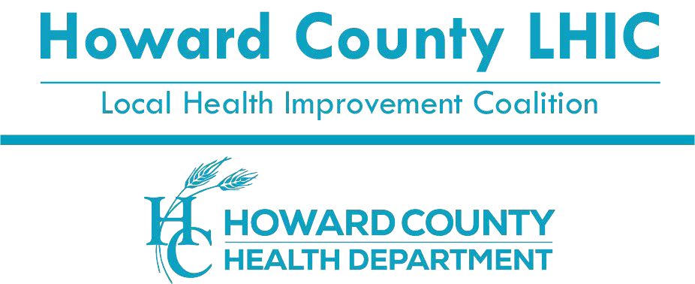
8930 Stanford Blvd | Columbia, MD 21045 410.313.6204 - Voice/Relay

410.313.6108 - Fax
1.866.313.6300 - Toll Free
www.hclhic.org

Howard County Food Security Committee Virtual Meeting via Zoom Thursday, August 3, 2023
11:00am to 12:00pm

Meeting Agenda
Meeting will start promptly at 11:00am
Meeting Goal: Convene collaborative Food Security Committee to reduce Food Insecurity and advance efforts towards Nutrition Security for Howard County residents.

11:00 – 11:10 Welcome
- Introductions
- Recap of last meeting minutes
- Member Announcements

11:10 – 11:20 Pop Up Panty Updates at Howard County Public School System
- Ducketts Lane Elementary School or Deep Run Elementary School
Carrie Ross, Food Bank Director, Community Action Council of Howard County

11:20 – 11:35 Substance Use Disorder Needs Related to Food Insecurity Discussion
Barbara Allen, Executive Director, James Place, Inc.

11:35 – 11:55 Nourishing the Futures Grant
- Mobile Food Pantry Van
- Eat Right, Be Bright Program
Annabelle Beavan, Founder/Executive Director, LindaBen Foundation Inc.

11:55 – 12:00 Wrap-up, and Next Steps

Next Food Security Meeting: Thursday, October 5, 2023, 11:00am to 12:00pm

Website: www.hclhic.org Facebook: www.facebook.com/hclhic Twitter: @hclhic

